{ TECHNICAL INTERVIEW }

SUBJECT:

Adventure book

Web application

DURATION:

2 hours

Note: We will check for solutions that have been copied or downloaded
from the internet which will disqualify you from the process.



Adventure book API

GOAL
Implement an interactive adventure book on a responsive web application using React / Tailwind, optionally enhance the backend.

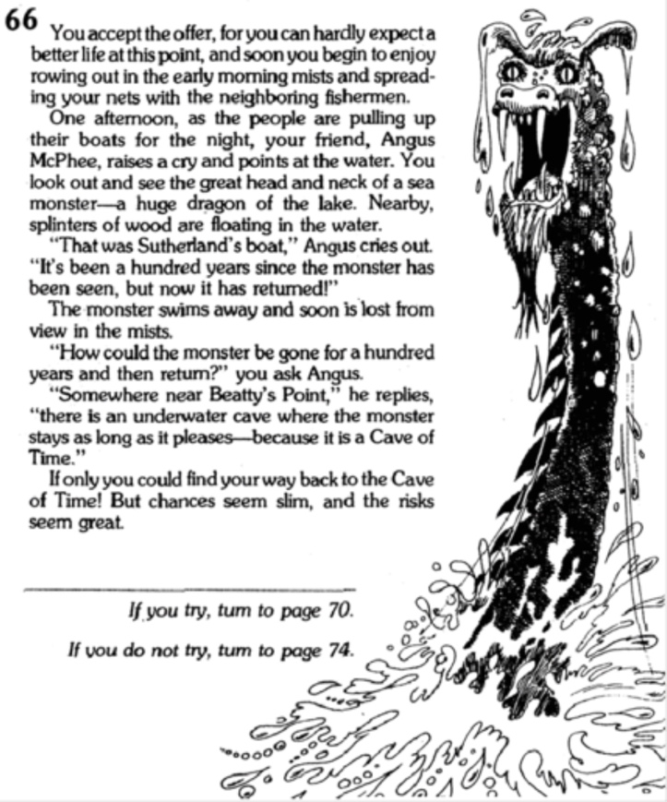
SUBJECT
Adventure books have been around for decades, immersing the reader-player in a fantastic and vibrant journey. This kind of book is composed of small, numbered sections, and at the end of each section, the reader can decide what the next step for their character will be. The book will then indicate to you which section you should read next, and so on.

Create a web application that allows a user to view the books, search, filter, play a game (succeed/fail), etc. To help you, a backend application is already available, exposing a REST API that should suit your needs. A README is also available to guide you in getting started.

A book is described as a JSON file. They are all available in the backend project under a specific folder. Be careful; a book file is invalid if any of the following conditions are met:
- Book has none, or more than one beginning
- Book has no ending (but can have multiple)
- Book has invalid next section id.
- A non-ending section has no options

The application needs to display a header allowing the user to stop/pause the game, view the current book name, their life, and save their progression. In the main content area, the user should see the text of the current section and a list of choices for navigation. The user can make a choice, and the application will jump to the next section until an ending section is reached (or the player dies).

How can a player die? Making a choice can have various consequences, and some of them are life-threatening. A player starts with 10 health points, and certain actions will affect this (such as combat, falling, etc.). Once health reaches zero, the player dies, and the adventure is over.

OBJECTIVES
When executing your application, the API should allow to:

Objective 1: Create a home page presenting the game, listing all the books, allosing a user to search and filter
Objective 2: Start a game and execute simple interactions (without the consequences mechanisms)
Objective 3: Handle consequences mechanism, user health points, game end
Objective 4 (extra): Improve UI/YX by adding current user life, progression within the book
Objective 5 (extra): Handle the save action on the backend and the capability to resume a game

We expect that objectives are treated in order.
Next pages present the expected design, and a sample of a JSON book file.

Expected design
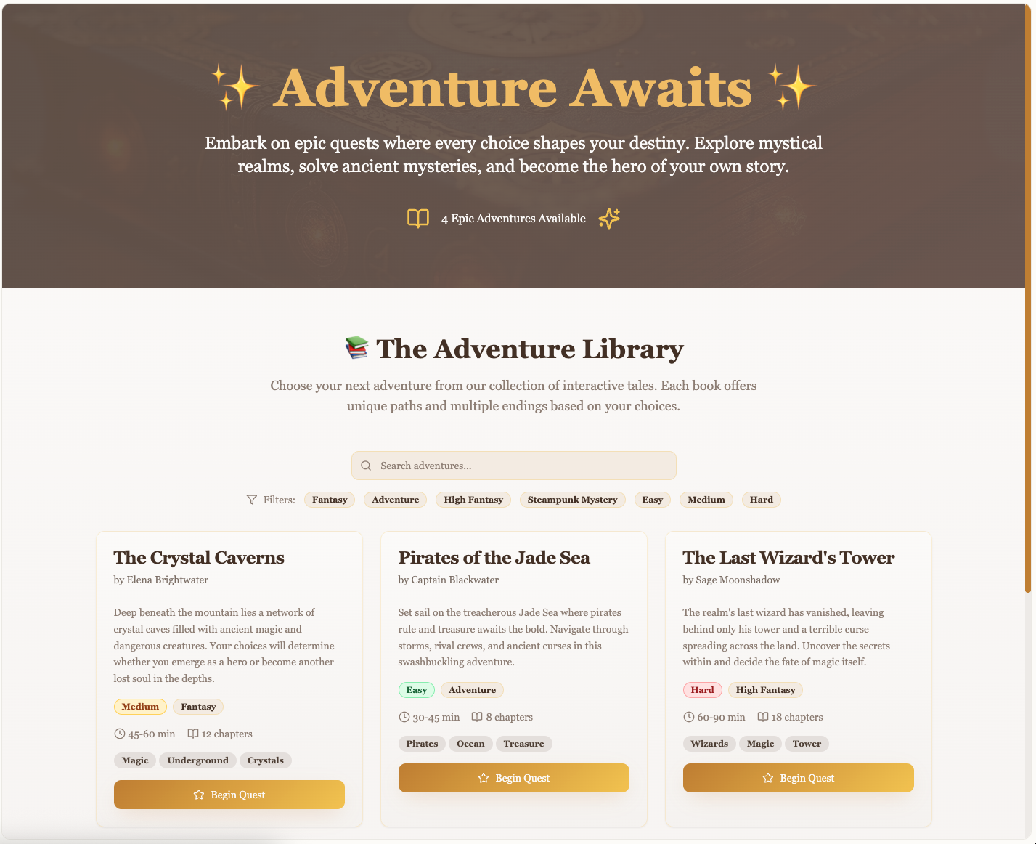
Figure 1 - Main Screen
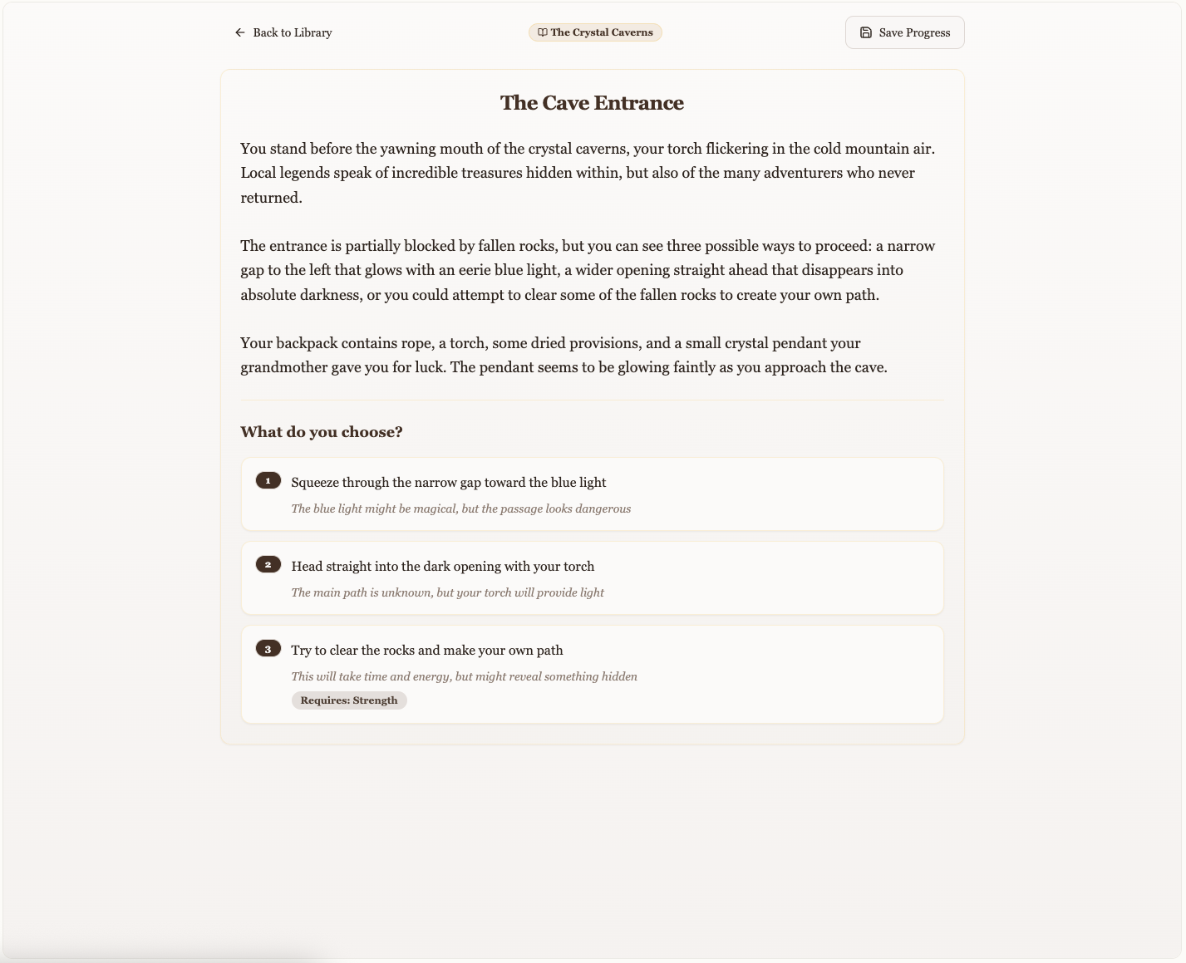
Figure 2 - Game Screen

